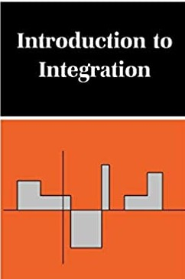

**BOOK REVIEW**

Review By :- Ankit Senjaliya

Roll Number :- 19BT04046

Presented To :- Dr. Dhaval Thakkar

* **Abstract** :-

The historical significance of the development of measure theory is that it created a base for a generalization of the classical Riemann notion of the definite integral (which since 1854 has been considered to be the most general theory of integration). Riemann defined a bounded function over an interval [a, b] to be integrable if and only if the Darboux (or Cauchy) sums ∑ni=1f(ti)λ(Ii)∑i=1nf(ti)λ(Ii) where ∑ni=1(Ii)∑i=1n(Ii) is a finite decomposition of [a, b] into subintervals, approach a unique limiting value whenever the length of the largest subinterval goes to zero. The French mathematician, Henri Lebesgue (1875–1941), assumed that the above subintervals (Ii)(Ii) may be substituted by more general measurable sets and, in addition, that the class of Riemann integrable functions can be enlarged to the class of measurable functions. In this case, we arrive at a more advanced theory of integration, which is better suited for dealing with various limit processes and which led to the contemporary theory of probability and stochastic processes.

# **Introduction** :-

Suppose your friend gives you a wooden stick. He asks you to break it. Can you do so? Yes, it will be very easy for you to do so. But what will happen if he gives you five to six sticks to break? It will not be that easy to break it. As the number of sticks increases it is difficult to break them. The process of uniting things is an integration of things. Similarly, in mathematics too, we have an integration of two functions. Integration is like drop by drop addition of water in a container. Let us get ourselves familiar with the concepts of integrations.

**Integration**, in [mathematics](https://www.britannica.com/science/mathematics), technique of finding a [function](https://www.britannica.com/science/function-mathematics) g(x) the [derivative](https://www.britannica.com/science/derivative-mathematics) of which, Dg(x), is equal to a given function f(x). This is indicated by the [integral](https://www.britannica.com/science/integral-mathematics) sign “∫” as in ∫f(x), usually called the indefinite [integral](https://www.merriam-webster.com/dictionary/integral) of the function. The symbol dx represents an [infinitesimal](https://www.britannica.com/science/infinitesimal) displacement along x; thus ∫f(x) dx is the summation of the product of f(x) and dx.

When a function f(x) is known we can differentiate it to obtain its derivative . The reverse process is to obtain the function f(x) from knowledge of its derivative. This process is called integration. Applications of integration are numerous and some of these will be explored in subsequent Sections. First, what is important is to practise basic techniques and learn a variety of methods for integrating functions.

## Definition :-

## The process of finding a function, given its derivative, is called anti-differentiation (or integration). If *F*'(*x*) = *f*(*x*), we say *F*(*x*) is an anti-derivative of *f*(*x*).

### 

### 

We write  *dx* = *F*(*x*) + *c*.

if *F’*(*x*) = *f*(*x*). We call this the indefinite integral of  *f*(*x*).

* **Examples** :-

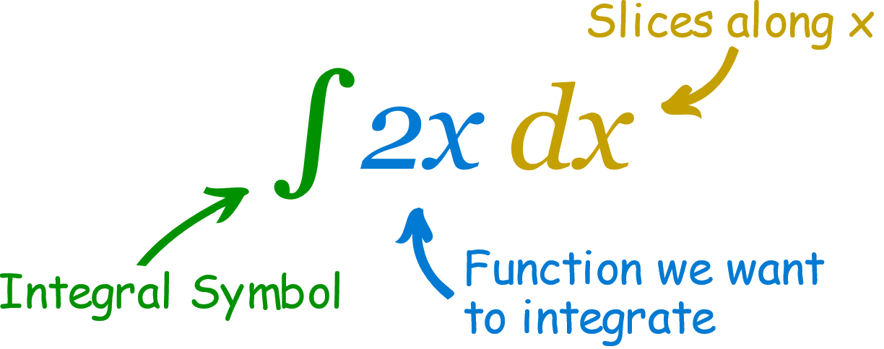



* **Constant Of Integration :-**

The constant of integration expresses a sense of ambiguity. For a given derivative there can exist many integrands which may differ by a set of real numbers. This set of real numbers is represented by the constant, C.

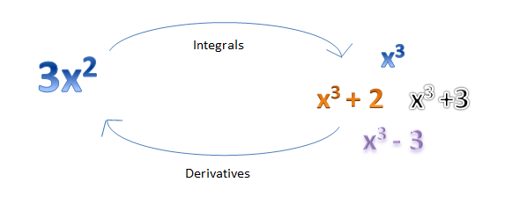

* **Types Of Integration :-**

There are two forms of the integrals.

* Indefinite Integrals
* Definite Integrals
* Indefinite Integrals:-
* It is an integral of a function when there is no limit for integration. It contains an arbitrary constant.
* Indefinite integrals are defined without upper and lower limits.
* A definite Integral is represented as:

∫f(x)dx = F(x) + C

* Where, C is any constant and the function f(x) is called the integrand.

### **Theorem = 1 :-**

The process of differentiation and integration are inverses of each other.

**Proof :-** Let F be an anti-derivative of f,

i.e.,

F(x) = f(x)

Then, ∫ f(x) dx = F(x) + C

∫ f(x) dx = [F(x) + C]

F(x) = f(x)

f'(x) = f(x) and hence ∫ f′(x) dx = f(x) + C

{ C is the constant of integration}

* **Theorem = 2 :-**

The integration of the sum of two integrands is the sum of integrations of two integrands.

∫ [f(x) + g(x)] dx = ∫ f(x) dx + ∫ g(x) dx

**Proof :-**

Using theorem 1, we have

[ dx] = f(x) + g(x) … (1)

Also, [ + ] = +

[ + ] = f(x) + g(x) … (2)

From (1) and (2), we have,

= +

* **Theorem = 3 :-**

For any real number k, ∫ k f(x) dx = k ∫ f(x) dx.

**Proof :-**

 Using theorem 1, we have

= k f(x) … (1)

Also, [] = k = k f(x) … (2)

From (1) and (2), we have,

∫ k f(x) dx = k ∫ f(x) dx.

The above result can be generalised to

= +   + … +  .

* We have been doing **Indefinite Integrals** so far.

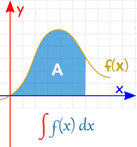

* **Examples :- Find the integral of the function**

**∫ x2 dx**

**Solution :-**

= ∫ x2 dx

= + C.

* DefiniteIntegrals **:-**
* An integral of a function with limits of integration. There are two values as the limits for the interval of integration. One is the lower limit and the other is the upper limit. It does not contain any constant of integration.
* An integral that contains the upper and lower limits then it is a definite integral. On a real line, x is restricted to lie. Riemann Integral is the other name of the Definite Integral.
* A definite Integral is represented as:

dx

* A **Definite Integral** has actual values to calculate between (they are put at the bottom and top of the "S")

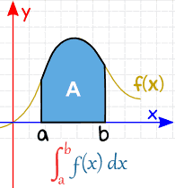

**Example :- Find the integral of the function:**

**Solution:-**

=

=  ( )dx

= () – ()

= 9

## Integration Methods :-

The different methods of integration include:

1. **Integration by Substitution**
2. **Integration by Parts**
3. **Integration Using Trigonometric Identities**
4. **Integration of Some particular function**
5. **Integration by Partial Fraction**

## Integration by Substitution :-

* Sometimes, it is really difficult to find the integration of a function, thus we can find the integration by introducing a new independent variable. This method is called [Integration By Substitution](https://byjus.com/maths/integration-substitution/)
* The given form of integral function (say ∫f(x)) can be transformed into another by changing the independent variable **x to t,**

Substituting x = g(t) in the function ∫f(x), we get;

= g'(t)

or dx = g'(t) dt

Thus, **I = ∫f(x) dx = f(g(t)) g'(t) dt**

## Integration by Parts :-

* It is a special kind of integration method when two functions are multiplied together. The rule for integration by parts is

= u –

Where

* u is the function of u(x)
* v is the function of v(x)
* u’ is the derivative of the function u(x)
* For deciding the first and the second functions, one can follow the **ILATE rule** for integration.

## Integration Using Trigonometric Identities :-

* In the integration of a function, if the integrand involves any kind of trigonometric function, then we use[trigonometric identities](https://byjus.com/maths/trigonometric-identities/) to simplify the function that can be easily integrated.
* Few of the trigonometric identities are as follows:

=

=

=

=

All these identities simplify integrand, that can be easily found out.

### **Integration of Some particular function :-**

* Integration of some particular function involves some important formulae of integration that can be applied to make other integration into the standard form of the integrand. The integration of these standard integrands can be easily found using a direct form of integration method.

***Also, read:***[Integration of some particular function](https://byjus.com/maths/integrals-particular-function/)

## Integration by partial fraction :-

* We know that a Rational Number can be expressed in the form of p/q, where p and q are integers and q≠0. Similarly, a rational function is defined as the ratio of two polynomials which can be expressed in the form of [partial fractions:](https://byjus.com/maths/partial-fractions/) , where Q(x)≠0.
* There are in general two forms of partial fraction:

1. **Proper partial fraction:**When the degree of the numerator is less than the degree of the denominator, then the partial fraction is known as a proper partial fraction.
2. **Improper partial fraction:** When the degree of the numerator is greater than the degree of denominator then the partial fraction is known as an improper partial fraction. Thus, the fraction can be simplified into simpler partial fractions, that can be easily integrated.

# **Prelude to Applications of Integration :-**

The Hoover Dam is an engineering marvel. When Lake Mead, the reservoir behind the dam, is full, the dam withstands a great deal of force. However, water levels in the lake vary considerably as a result of droughts and varying water demands. Later in this chapter, we use definite integrals to calculate the force exerted on the dam when the reservoir is full and we examine how changing water levels affect that force. Hydrostatic force is only one of the many applications of definite integrals we explore in this chapter. From geometric applications such as surface area and volume, to physical applications such as mass and work, to growth and decay models, definite integrals are a powerful tool to help us understand and model the world around us.



# **Areas between Curves :-**

* **Learning Objectives :-**
* Determine the area of a region between two curves by integrating with respect to the independent variable.
* Find the area of a compound region.
* the area of a region between two curves by integrating with respect to the dependent variable.
* In Introduction to Integration, we developed the concept of the definite integral to calculate the area below a curve on a given interval. In this section, we expand that idea to calculate the area of more complex regions. We start by finding the area between two curves that are functions of xx, beginning with the simple case in which one function value is always greater than the other. We then look at cases when the graphs of the functions cross. Last, we consider how to calculate the area between two curves that are functions of y.

### **Area of a Region between Two Curves**

* Let f(x) and g(x) be continuous functions over an interval [a, b] such that f(x) ≥ g(x) on [a, b]. We want to find the area between the graphs of the functions, as shown in Figure

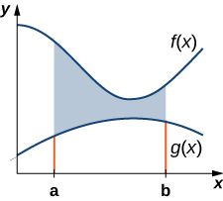

# **Integrals, Exponential Functions, and Logarithms :-**

* **Learning Objectives :-**
* Write the definition of the natural logarithm as an integral.
* Recognize the derivative of the natural logarithm.
* Integrate functions involving the natural logarithmic function.
* Define the number e through an integral.
* Recognize the derivative and integral of the exponential function.
* Prove properties of logarithms and exponential functions using integrals.
* Express general logarithmic and exponential functions in terms of natural logarithms and exponentials.
* We already examined exponential functions and logarithms in earlier chapters. However, we glossed over some key details in the previous discussions. For example, we did not study how to treat exponential functions with exponents that are irrational. The definition of the number e is another area where the previous development was somewhat incomplete. We now have the tools to deal with these concepts in a more mathematically rigorous way, and we do so in this section.
* For purposes of this section, assume we have not yet defined the natural logarithm, the number e, or any of the integration and differentiation formulas associated with these functions. By the end of the section, we will have studied these concepts in a mathematically rigorous way (and we will see they are consistent with the concepts we learned earlier). We begin the section by defining the natural logarithm in terms of an integral. This definition forms the foundation for the section. From this definition, we derive differentiation formulas, define the number e, and expand these concepts to logarithms and exponential functions of any base.

# **Conclusion:-**

* Conclusion With integration and differentiation as mathematical techniques, I have been able to reach the solution of the different methods used. Each of the methods brings a simple and clear way thus can be used for practical data. Furthermore, with tables and figures I have been able and compare the actual data with the predicted data.
* The analyzing of the different countries that are less developed has given an overview of how overpopulation will cause severe problems for example instability, showing the country’s development, the viscous poverty circle, pollution and environmental degradation.
* Using the techniques above I have been able to predict population sizes with and without family planning. For example I analyzed the family planning policy in china and evaluated how it has advantageously helped china in its development and poverty reduction.
* Therefore, it will be true if I say that other developing and underdeveloped countries deserve to emphasize on the implementation of the family planning rule in order to reduce the negative impacts of massive population that has affected our world.
* This project can therefore be viewed as a scientific effort to measure and manage population growth in the current world setup. It can also help struggling or developing nations adopt some of the method displayed above to improve their social and economic status.
* **REFERENCES :-**
* Google.com
* Notes On Discrete Mathematics by James Aspnes (pdf)